E-Factor Group Ltd Insurance Tender 2021 to 2022/4

Tender Details & Frequently Asked Questions from Insurers

- Who are your current Insurers?
Hiscox Insurance to 30th June 2021
- Details of any claims in past 5 years:
There has been one claim of £8,672.97 in the last 5 years which covered minor cracking caused by an adjacent tree in the footpath at 64 St Peters Avenue. This work was completed in 1st quarter of 2021.
We have never had a claim under Professional Indemnity.
- Size and specifications of the 2 platform lifts?
The two platform lifts are personnel carriers at the Village and Dudley St Sites for 4 to 6 people.
- Size and specifications of the 44 Boilers?
The 44 boilers are largely domestic type boilers and 3 are commercial boilers for general heating at the Village and Dudley St sites. As we understand it, these are not considered to be pressure vessels. The boilers are tested and serviced on an annual basis using a ‘GAS Safe’ registered company.
- Details of Employee numbers and estimated annual wage roll split between each category of staff?
Employee details:
  - e-factor currently have 20 staff, but this may vary by plus or minus 2.
  - We have no volunteers.
  - All maintenance work is subcontracted.

- Annual Wage roll
  - Actual 2020 to 2021: £600,706
  - Budgeted 2021-2022: Circa £660,000
- Annual Income
  - Actual Projected 2020 to 2021: £1,349,048
  - Budgeted 2021 to 2022: £1,582,000
- There are no significant changes to any of the following activities: properties, equipment, plant, etc
- Personal Accident – operative times – 24 hour or occupational duties only?
Personal Accident is to cover duties whilst on official company business and commuting to and from work and cover is 1*Annual salary and weekly 50% Salary.
- Estimated annual Revenue/Income, split by activity April 21 to End March 22
Estimated annual revenue / Income Rental / Hive income £846,760, Recharged Services £58,614 Miscellaneous Income £52,625, Virtual Businesses £13,700, Facilities Management £49,170, Solar Income £12,862 and Room Hire £10,320. We also operate with grant funding and contracts, for this year 2021/22 it is estimated to be approximately £597,000.
- Professional Indemnity – details of what advice is being provided and by which Employees
We currently have 7 business advisors providing advice and guidance and they are experienced Business Advisors. As a not-for-profit social enterprise, we do not charge SMEs for our business advice and support as this paid for through funding and the revenue generated as above.
We provide Advice and guidance only and are not involved in any design or development processes.
- Details of Property Letting.
- Our leases are a mixture on ‘easy in, easy out’, subject to 3 months’ notice but others are longer term fixed ranging from 3 to 5 years.
- Over the last year our occupancy level has been around 95% across the whole portfolio.
- We cannot specify the current occupancy trades per unit/office as this can change with changes in tenancies as we are a business support organisation, and any insurance must be flexible to allow changes in tenancies and type of business.
- Please can you advise specification of the composite panelling at the Enterprise Village Site?
Building Descriptions:
The Enterprise Village
Building description at the Enterprise Village for which we do not have individual valuations for each block but provide details of the composition of each block. This site was a new build completed in November 2010 and is a cladded construction over breeze block lower structure. We have subsequently built a new block F, completed in January 2021.
All units at the Enterprise Village have fire detectors and individual burglar systems that are 24-hour, 365 day monitored. There is also CCTV that is monitored 24*7*365 and security guards are sent in event of alarms.
  - Block A comprises 2 joined units 103sqm each.
  - Block B comprises 4 x 103sqm units and 3 units of 186sqm.
  - Block C comprises 2 x 103sqm units, 2 units of 186sqm each and 1 larger unit of 243sqm
  - Block D comprises 2 x 103sqm units, 2 units of 186sqm and a larger unit of 243sqm.
  - Block E comprises 1 unit of 273sqm, 2 units of 105sqm, 2 units of 157sqm, a Café of 108sqm and a 2-story office block comprising reception area, e-factor company offices, plus 8 ground floor lettable offices and 4 first floor lettable offices along with a board room, training room, archive room and 3 small meeting rooms on the ground floor.
  - Block F comprises 7 joined units of which 6 are 175 sqm and 1 is 145sqm
  - All above dimensions/areas are approximate.

For details and specifications of insulated cladding panels (Block A to E) open the embedded PDF document “KS600-1000 AWP Range PDS.PDF” below:

(‘Double Click’ on the file to open in Adobe Acrobat)

The Following PDF File “Overall Layout.pdf” shows the general layout plan of the Enterprise Village site:

(‘Double Click’ to the file to open in Adobe Acrobat)

Additional Properties:
These buildings are typically traditional construction of brick, and /or insulated cladding mostly with either traditional tiling or, where there are workshops, with insulated cladding sheets.
64 St Peter’s Avenue, Cleethorpes
170-172, Yarborough Road, Grimsby
84 Wellington Street, Grimsby
Willows Building, Crosland Road, Grimsby
10 Railway Street, Grimsby
The business Hive, 13 Dudley Street, Grimsby
352 Pelham Road Immingham
54 Pelham Road, Immingham

At our site at 352 Pelham Road, Immingham there is a part pitched sheet roof, part pitched corrugated compressed asbestos sheet roof and a small section of flat roof that has been recently refurbished.

At the Willows site on Crosland Road, the Social club, which is a licenced premise, has a pitched tile roof and the office block part of the facility has a series of different level flat roofs.

I am unsure of the age of all buildings, but all have been significantly refurbished following purchase from 2008 to 2010.
- Can you please provide us with a copy of your existing PI details?
Insured - E-Factor Group Ltd.
Department – Business Assistance.
Services - Business Support and Guidance.
Change in Business Activities – The type of work has not changed over that covered for 2020 to 2021.
Changes in personnel – Senior & supervisory staff are appropriately qualified with at least 3 years’ experience.
However, we do not charge fees to our clients as we are a funded social enterprise organisation and our income therefore arises out of funding and income arising from rental of our portfolio and Hive Club membership.
After individual enquiry by us there are no staff, who are involved in the provision of the Services, that are aware of any circumstances which may give rise to a claim against the Insured or personally against any present or former employee of the Insured.
- There is an item for Plant protection. Is this full breakdown cover or sudden and unforeseen damage?
Plant protection is for sudden and unforeseen damage not general maintenance.

Continued on the following page…

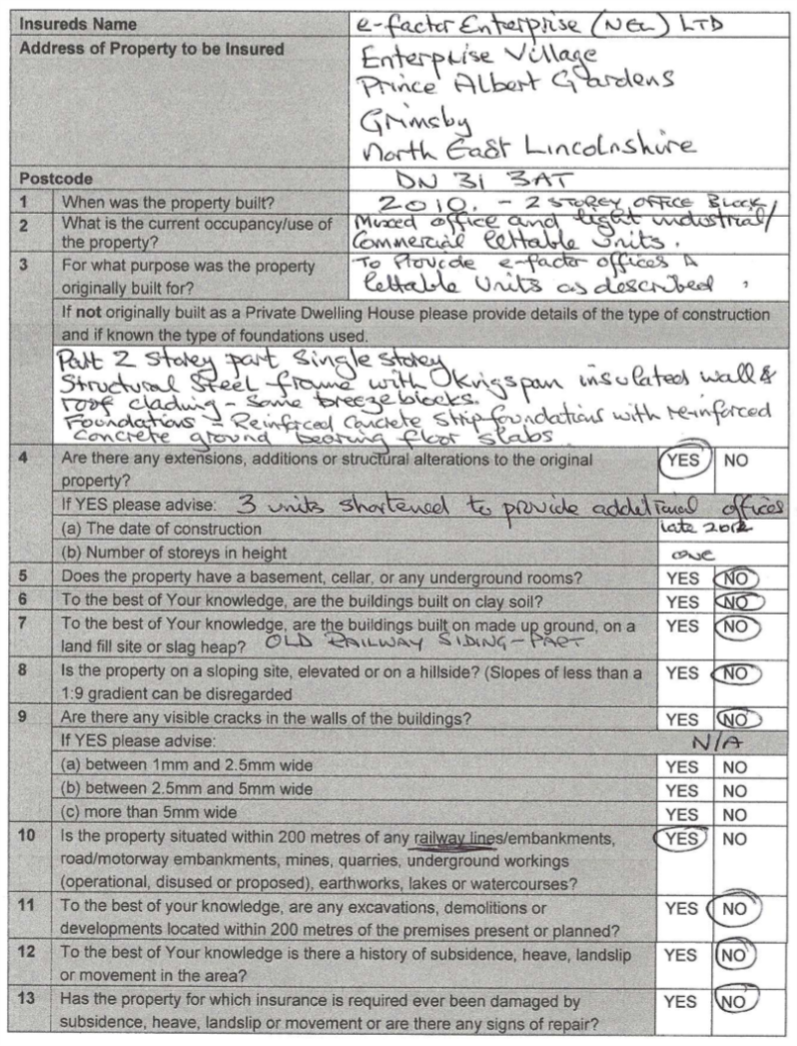
- Subsidence Information – Recently Built Property (2010): Enterprise Village

